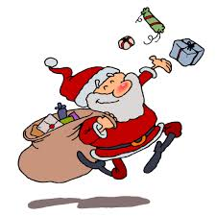

Here are the winners in our 2017
“12 Days of Christmas” Raffle:
December 7, 2017
Gift Card Tree:
KRYSTAL LAKEMAN Ticket # 0806
December 8, 2017
Pamper Your Vehicle:
MELISSA BODDEN Ticket # 0892
December 9, 2017
The Great Outdoors:
JESSICA VANSTRIEN Ticket # 1545
December 10, 2017
The Maintenance Group:
TANYA LLOYD Ticket # 0742
December 11, 2017
Hit the Slopes:
JENNY HUDDER Ticket # 0173
December 12, 2017
Be Prepared:
KYLAH KUSSMANN Ticket # 0042
December 13, 2017
Skating Party;
WAYNE YOUNG Ticket # 1037
December 14, 2017
Capturing the Memories;
CHRISTINE BELISLE Ticket # 0017

December 15, 2017
Build Me A…
JESSICA O’REILLY Ticket # 0548
December 16, 2017
Shape up/Change up;
WAYNE WHITE Ticket # 0078
December 17, 2017
When all Through the House;
VICKI COLE Ticket # 0526
December 18, 2017
Pamper Yourself;
TRACEY RUTLEDGE Ticket # 1281

December 19, 2017
$300.00 Cash Prize
SHERRY SARARAS Ticket # 0963

Winner of our TV Raffle: Danette Rushnell

Winner of Incentive Prize (TV)
Wannamaker family

